Cerebral Palsy Sport

Marketing and Communications Officer
Applicant Information Pack - April 2022

Dear Applicant
Thank you for showing an interest in the post of Marketing & Communications Officer with CP Sport. We have a friendly and welcoming team and are excited to have introduced this new role within the team. We are looking for an individual who is enthusiastic, creative and social media savvy.
This pack is designed to provide you with a brief overview of CP Sport and what we do as well as a full job description and person specification for the role.
About Cerebral Palsy Sport
CP Sport is the national disability sports organisation supporting people with cerebral palsy to be able to access and enjoy being physically active throughout their lives​.

We collaborate with local, regional, and national partners to provide physical activity that is accessible and enjoyable for people with cerebral palsy – children, young people and adults, all across the UK. We support everyone with cerebral palsy to have the opportunities, capability, and motivation to participate in a wide range of physical activities and which suit a variety of interests. ​
​
We work hard to make physical activities accessible for everyone with cerebral palsy. Our expert specialist support for parents, support workers, teachers, coaches, physiotherapists, occupational therapists, sport providers and other professionals enable sport and sessions to be adapted to suit individual needs.

Our friendly and welcoming community brings together people with cerebral palsy, their families and friends, volunteers and those working in the disability sport sector who provide local and national opportunities. We are part of a vibrant network, we collaborate with partner organisations, working together to break down barriers that prevent disabled people from enjoying active lives.​
​
We are here to enhance the lives of people with cerebral palsy and the wider disability sport community. Signposting to local, accessible activities and campaigning with our members, fundraisers and partners, we raise awareness of cerebral palsy, as well as the physical and mental health and wellbeing benefits of being active.​ Becoming physically active is life enhancing – increased confidence, increased motivation, reducing social isolation, not to mention the range of mental and physical wellbeing benefits which can improve daily life in the long term.
CP Sport Strategy 2022-25
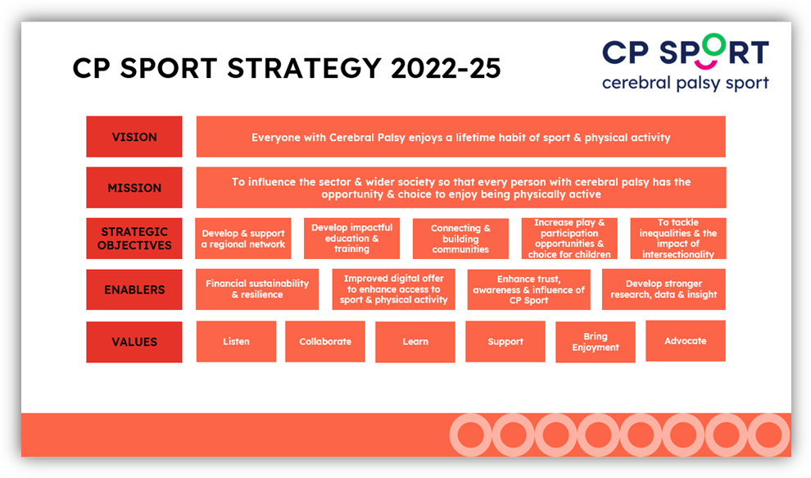

Our vision is that everyone with Cerebral Palsy enjoys a lifetime habit of sport & physical activity.
Our mission is to influence the sector and wider society so that every person with cerebral palsy has the opportunity and choice to enjoy being physically active.

Our values are important to us. We will:
- Listen to our community and work together to find solutions to achieve our vision
- Collaborate with others from within the sector and from outside of the sector, we can’t achieve our vision on our own
- Learn from our successes, our mistakes and from others, enabling CP Sport to be an agile, dynamic and innovative organisation
- Support people with cerebral palsy to lead an independent and active life
- Bring enjoyment and fun to our work, to our programmes and events and ultimately to our community
- Advocate to raise the level of equity within the sport and leisure sector and remove systematic barriers and social exclusion for people with cerebral palsy

Our structure:
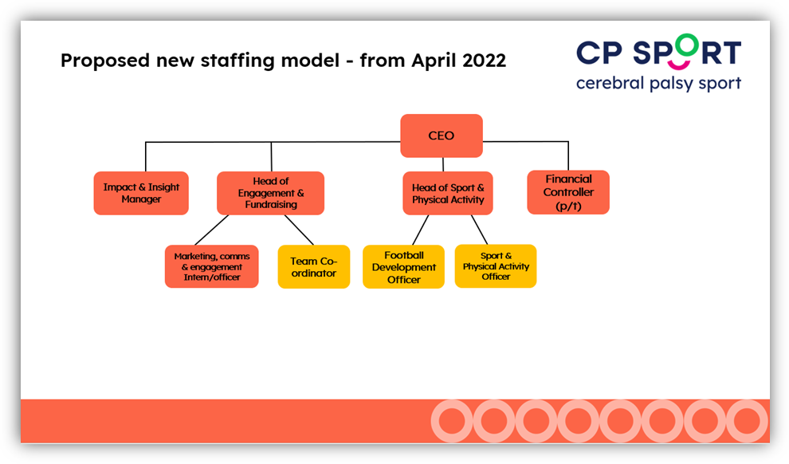

Commitment to Equality Diversity and Inclusion
Cerebral Palsy Sport is an equal opportunities employer, committed to equal opportunities policies. We welcome applications from anyone regardless of their age, disability, ethnicity, heritage, gender, sexuality or socio-economic background.
We are deeply committed to inclusive working practices, so during the application process we commit to:
- Paying for childcare whilst you’re at CP Sport interviews
- Paying for your travel costs to the interviews if these are held in person
- Making reasonable adjustments - for example ensuring we have sign language interpreters organised in advance if you’d like them.
- Providing this document in a Word document format readily available to download.
- Offering a guaranteed first stage interview for disabled candidates who meet the minimum requirements for the role.
If there is anything else you’re concerned about or think we could provide, please let us know.

To apply for the role of Marketing & Communications Officer:
Please email your CV, a covering letter (2-page maximum outlining how your skills and experience would enable you to be successful in this role), and a completed diversity monitoring form to: sandydrummond@cpsport.org

The closing date is 12pm Friday 13th May with online interviews to be held shortly after this deadline.

If you have any questions regarding the position, please contact Sandy Drummond, Head of Fundraising & Engagement via email: sandydrummond@cpsport.org

Job Description
Job Title: | Marketing & Communications Officer
Reporting to: | Head of Fundraising & Engagement
Salary: | 19,000 per annum
Location: | Home based
Type of contract: | Full time, permanent (interns may apply for a 1 year term)

Purpose:
The Marketing & Communications Officer will be an important addition to the CP Sport team as the charity continues to develop reach and awareness. This position will play a key role in showcasing the CP Sport brand and to engage with beneficiaries and stakeholders. Priorities include managing digital content and platforms, using digital data to inform marketing activity, and developing a variety of forms of content for campaigns.
Key duties and responsibilities:
- Support the implementation of the CP Sport marketing and digital strategy
- Ensure the CP Sport brand is represented in a consistent manner
- Develop creative content and resources
- Follow and understand inclusive communications guidelines
- Update the CP Sport website (WordPress plus 3rd party integrations)
- Manage social media platforms including scheduling content and responding to comments and messages.
- Write and edit news stories, press releases and newsletters
- Engage with the CP community and wider community as needed for example surveys, interviews and case study collation.
- Develop positive relationships with media locally, regionally and nationally
- Manage free or paid adverting opportunities including google ads and social media campaigns
- Travel and support media days, events and exhibitions
- Contribute to the charity’s monitoring and evaluation processes and use digital analytics to measure effectiveness of campaigns and understand customer interaction
- Contribute to internal communications
- Support the CP Sport Ambassador programme and identify social trends and influencers to enhance awareness and fundraising activity
- Support partner and relevant awareness campaigns
- Communicate with external suppliers such as printing companies

Any other duties
To undertake any other appropriate duties as determined by the Head of Fundraising & Engagement

Person Specification
 | ESSENTIAL | DESIRABLE
Education and Qualifications
Media and communications |  | √
Digital marketing |  | √
Knowledge, Skills and Experience
Graphic design experience with an eye for detail | √
Google analytics |  | √
Social media platforms (content creation, planning, analytics) | √
Use of WordPress or equivalent | √
Writing experience (e.g. newsletters, press releases) | √
Setting up google ad campaigns |  | √
Video editing |  | √
Ability to engage positively with a wide range of audiences and demonstrate excellent inter-  personal skills | √
Experience of working with press |  | √
Great time management skills and ability to manage multiple projects to deadlines | √
Experience of fundraising or charity work |  | √
Experience of working with disabled people |  | √
Interest in sport |  | √
Personal Qualities
Ability to be a strong advocate for the CP Sport brand and work within guidelines | √
Passionate and committed | √
Creative thinker | √
Pragmatic and flexible | √
Good team player | √
Commitment to the principle of Equality and Diversity | √
Ability and willingness to travel within the UK | √

This post is subject to an Enhanced Disclosure check via the Disclosure Barring Service
Cerebral Palsy Sport is an equal opportunities employer. All appointments are made on the basis of merit and ability.

